GOVERNMENT KAMALANAGAR COLLEGE
PROACTIVE DISCLOSURE UNDER SECTION 4(1) (B) OF THE RTI ACT, 2005
(As required under Clause 4 (1) (b) of the Right To Information Act, 2005, Government Kamalanagar College, Kamalanagar, Chawngte, Mizoram, has made Declaration as follow)
Government Kamalanagar College is co-educational Under Graduate (UG) Degree College, and abbreviate as GKNC. It is located in Kamalanagar, Chawngte, the Headquarters of Chakma Autonomous District Council (CADC) in Mizoram. The area was purely Tribal belt, as enshrined by the Sixth Schedule of the Constitution of India. It was bounded by 318 km of Indo-Bangladesh border in the West, and 404 km of Indo-Myanmar border at the south, and the CADC was at the tip of India international border in Mizoram state. Entirely, it is Tribal inhabited area, where majority of the population is Chakma (Tribal), but different other tribal communities, like Bawm (Mizo), Pang (Mizo), Tlanglau (Mizo), Bru, other Mizo sub-tribes, and few businessmen of non-tribal communities subsistent their lives in the headquarters and nearby villages. GKNC is mono-Institute, and offer ‘Arts’ stream only.
Manual - 1:
1. Objective / Purpose of the Institute. Major Objectives of the College are as follows:
- To streamline student’s potentiality
- To provide up-to-date knowledge and skill
- To provide opportunity for social service through education
- To generate leadership qualities
- To propagate Sense of National Unity & Spirit
- Physical fitness through NSS Wings
- Service Mankind
- Feeling of Secularism
- Environment Awareness and Prevention
- To uphold moral values of life
2. Mission/ Vision Statement of the Institute
(a) Vision –
GKNC aims at imparting futuristic education to its students and instills high patterns of discipline through its dedicated and ambitious staff that set a global standard, making our students intellectually superior and ethically strong. To build up the national character the development of the individual character is a must. It is our motto to help build the character of our students through the following:
“WORK HARD CLEAR VISION IRON WILL”
By accomplishing the above vision, the college envisages to improve the quality of life across all areas of life and livelihood. We believe that the individuals make the nation.
(b) Mission –
We, at Govt. Kamalanagar College, is committed to educate students from all walk of life, particularly the rural youths from Chakma and Mizo community, so that they become enlightened citizens of tomorrow and can earn a respectful life for themselves and their family. By the very nature of the task, we are bound by our duty to provide individual attention and impart the best of education to our students within the resources available to us.
3. Brief History of the institute and the context of its formation.
Govt. Kamalanagar College was started by some aspire educationists on 4th April, 1992, and give student admission for Higher Secondary or 10+2. The word Government is added after the Government of Mizoram provincialised in 2013. Initially teacher’s recruitments were done through advertisement and inviting qualified persons from all over the country. The institute was purely ‘Private College’, but sooner or later, the Government of Mizoram has given the status of ‘Deficit College’ on 1st January 2007. With this new status, the State Government provides annual financial ‘Lump-Sum Grant’ to the institute, and many of the financial gaps were enlightened.
On 30th July 2009, Mizoram University (MZU) has granted ‘Permanent Affiliation’ (Vide No. MZU//CDC/1/19/09/380, dated 30th July 2009). Simultaneously, the College was ‘Provincialised’ to purely Government College on 19th September, 2013 (No.B.16013/1/2007 the dated 19th Sept.2013). With this Provincialisation Order, the Government of Mizoram absorbed all the Staffs (Teaching and Non teaching) of the College to Government Servant, and the properties of the institute go to the state authority. The Apex authority of Higher Education in India, i.e., the UGC (University Grants Commission), has given recognition under 2 (f) and 12 B of the UGC Act, 1956 on 30th July 2010 (Vide F.No.8-271/2009(CPP-I/C) Dt.30.07.2010). Unfortunately, the whole campus caught fire on the midnight of 29th August 2012, and there was nothing left, rather, the whole buildings, library books, office records and furniture turned into ashes within a night. There was no life lost, but the students have no class room, and teachers has to continue teaching under the tree and wherever possible, for almost half year. The total lost was calculated to the tune of 3.5 crore (approx), and the incident or lost was reported to the Governor of Mizoram, Minister i/c Higher & Technical, Vice Chancellor (MZU), Deputy Commissioner of Lawngtlai District, Office of UGC-NERO, Regional Centre of IGNOU, and other officials. In fact, the College begins with its presence status since the academic session of 2013-2014 only.
4. Duties of the institute. To engage in teaching as laid down by the Government of Mizoram, Affiliating University and UGC
5. Main Activities/ Functions of the college: Teaching and other extension activities.
6. List of services being provided by the college with a brief write up on them.
The major services being provided are as follows: -
(i) Teaching and Learning
(ii) Library Services
(iii) IT Services
(iv) Spoken English & Hindi
(v) Hostel services
(vi) Canteen services
(vii) Provision of electricity, water supply and other allied services.
(i) Teaching & Learning: The teaching and learning at Govt. Kamalanagar College involves the preparation of teachers for completion of syllabus, regular evaluation and execution of needs of the students during the course of study.
(ii) Library Services -: Library has been updated with collection of text books in volumes, journals, magazines, etc. Library provides systematic access for reading and borrowing text books to both faculty and students. Library services are fully computerized with software.
(iii) IT Services: IT Services provide Information Technology Services to the diverse technology needs of students under the guidance of BCA degree holders.
(iv) Spoken English & Hindi : Students are free to have training on Spoken English and Spoken Hindi. Two Language departments i.e., English and Hindi, were assigned to take classes at regular intervals.
(v) Hostel Services: Hostels for both boys and girls are available. A student seeking admission to the hostel shall have to submit application for hostel accommodation that he/she is also aware of the law in this regard and agrees to abide by the punishments meted out if he/she is found guilty of ragging and/or supporting ragging. Communication devices shall be permitted in hostels to provide access to the students particularly fresher, to reach out for help from teachers, parents and institution authorities.
(vi) Cafeteria Services: A Cafeteria is available in the campus which caters according to the need of students, faculties and staffs.
(vii) Provision of electricity, water supply and other allied services: Electricity is provided to serve the needs. A generator has been installed to provide uninterrupted power supply. Potable water is supplied from Water Cooler, the connection provided by PHE (Physical Health Engineering) of CADC (Chakma Autonomous District Council).
7. Organization of the institute: Organizational structure
Government of Mizoram
ADMINISTRATION

Principal
Head Assistant
UDC
LDC
IVth Grade

DEPARTMENTS

Head of Department
Associate Professor
Assistant Professor
LIBRARY
Librarian
Staffs
(As assigned by the Principal)
IQAC & RUSA

Coordinator
Computer Operator

8. Expectation of the institute from the public for enhancing its effectiveness and Efficiencies.
Not applicable
9. Arrangements and methods made for seeking public Participation / contribution:
The following extension activities are being organized for seeking public participation and creating awareness among the local community-
NSS (National Service Scheme) Regular activities and Special Camping, as well as by declaring Adopted Village (NSS) viz., Udalthana village, Baganpara village, Tuikhurlui village.

10. Mechanism available for monitoring the service delay and public grievance resolution:
Complain Box is made in the campus, and diverse grievances can be resolved.
11. Address:

Kamalanagar, Chawngte, Mizoram
PIN : 796772
Phone : 0372-2563078
E-mail Id. : collegekama@gmail.com
Website : www.gknc.in

12. Working hours : 9.30 am to 4.30 pm (Winter)
9:00 am to 5:00 pm (Summer)
#According to the Government Notice

Manual - 2:
The Powers and Duties of Officers and Employees:-
Sl. No. | Designation | Duties
1. | Principal | - Principal is the Head of the Institution, vested with the powers of superintendence, control and supervision of all the affairs of the college under the Government Rules and Regulations  - Principal is the Drawing and Disbursement Officer (DDO)  - Principal shall be chief superintendent of examination
2. | Head of Department | - Maintenance and smooth functioning of the departments, theory classes, practicals  - Responsible to motivate faculty to publish research articles  - Responsible for identification of staff requirement and selection.  - Responsible for subject allocation, selection of electives, distributing periods and allocation of department work  - Reporting to principal on any cases related to department.  - Carryout examination related duties and functions.  - Teaching, and completion of courses; Internal marks.
3. | Associate Professor | - Maintenance and smooth functioning of the departments.  - Other functions assigned by the authorities.  - Teaching, and completion of courses; Internal marks.  - Carryout examination related duties and functions.
4. | Assistant Professor | - Teaching, and completion of courses; Internal marks.  - Maintenance and smooth functioning of the departments.  - Other functions assigned by the authorities.  - Carryout examination related duties and functions.
5. | Librarian | - Supervision of the Library works  - Responsible for issue / return of books  - Responsible for maintaining and upgrading library computer.  - Shall allot accession numbers and call numbers for books.  - Shall maintain reference books, general books, periodicals and back volumes.  - Responsible for collecting dues / charges, if any.  - Coordinate with various departments.  - Responsible for maintaining discipline in the library.
6. | Head Assistant | - Supervision of Establishment Office  - Assisting the Principal  - Coordinating various departments, and the staffs.  - Ensuring routine works of the Principal Office.  - As directed by higher authorities
7. | Upper Div. Clerk (UDC) | - Assisting the Principal  - Assisting the Head Assistant  - Preparation of Pay bill / LPC  - Calculation of Salary related matters  - As directed by higher authorities
8. | Lower Div. Clerk (LDC) | - Assisting both the Principal and HA / UDC  - Ensuring Establishment works  - As directed by higher authorities.
9. | Computer Technician | - All matters of computer, and IT  - As required by various departments, and offices  - As directed by higher authorities
10. | IVth Grade | - Securities, Cleanliness and Safety of the College  - To assist the Offices, and staffs.  - As directed by higher authorities.

Manual – 3
(1) The Procedure followed for decision making process, including channels of supervision and accountability.
The Head of Department, in consultation with faculties of their respective departments, distribute topics. Every Faculty’s teach the students accordingly. Teachers assess Internal Marks by conducting Internal Examination and Assignment to the students, these are done under the Guidance of the HoD. In order to decides important Agendas, the Principal calls for Staff Meetings, and discusses various Agenda’s of diverse nature. Consequently, the Principal give his signature, and the decision of the Staff Meeting/Committee is final. In other routine business, the Principal decides according to the formalities given by the government.
(2) What are the arrangements to communicate the decision to the public?
Following are the arrangements: -
(a) Direct classroom communication: Direct class room communications are made to students wherever applicable.
(b) College notice board: On notice boards, circulars of the College is displayed promptly to avoid delay in any important communication.
(c) College Website: http://www.gknc.in
(d) Telephone Call
(3) Who are the officers at various levels whose opinions are sought for the process of decision making?
Head of Department, Coordinator of IQAC, Coordinator of RUSA, and Staff Meetings.
(4) Who is the final authority that vets the decision?
Principal is the final authority to vet the decision.
(5) Please provide information separately in the following format for the important matters on which the decision is taken by the public authority.
Not applicable
Manual – 4:
The Norms set by it for the discharge of its functions: -
Administrative & Service Manual | Not applicable
From where one can get a copy of Rules, Regulation, Instruction, manual and Record (if any) | Directorate, Higher & Technical Education Department, Govt. of Mizoram
Fee charges by the department for rules, regulation, instruction, manual and records (if any) | Not applicable
As the college is under the Government of Mizoram, Notification is made by the government, time to time.
Manual – 5:
The Rules, Regulations, Instructions, Manuals and Records, held by it or under its Control or used by its Employees for discharging its Functions:
16. Following are the manuals and records: -
(a) Enrolled students record/Admission register
(b) University statutes regulations, ordinances, notifications and circulars.
(c) Marks registers
(d) Furniture and fixtures registers
(e) Stock register

Manual – 6:

A Statement of the Categories of Documents that are held by it or under its control:
Use the format given below to give the information about the official documents. Also mention the place where the documents are available for e.g. at Secretariat level, directorate level, others (Please mention the level in place of writing “Others”).
Sr.No. | Category of the Document | Name of the Document and Its Introduction on Online | Procedure to obtain the document | Held by / Under control of Principal of College
1. | Admission Form | Available | As per Government Policies | College Office
2. | Enrolment List | Not Available | As per Government Policies | College Office
3. | Petty Cash Book | Not Available | As per Government Policies | College Office
4. | Stock Register | Not Available | As per Government Policies | College Office
5. | Student Handbook | Not Available | As per Government Policies | College Office
6. | Scholarship | Not Available | As per Government Policies | College Office

Manual – 7:
The Particulars of any arrangement that exists for consultation with, or representation by, the members of the public in relation to the formulation of its policy or implementation thereof:-
Sr. No. | Subject / Topic | Is it mandatory to ensure Public participation (Yes / No) | Arrangements for seeking public participation
Not Available
17. The institution depends on the Notification/Orders/Circulars of the Government of Mizoram, UGC and Mizoram University (Affiliating University).

Manual – 8:

18. A Statement of the Boards, Councils, Committees and other Bodies Consisting of Two or more Persons constituted as its part those Boards, Councils, Committees and other Bodies are open Minutes of such Meetings are Accessible for Public:

Not Available

Manual – 9:

19. A Directory of its Officers and Employees.

A. OFFICERS (PRINCIPAL AND TEACHING FACULTY):-

Sl.No | Name | Post | Remarks | Phone No.
1. | Mrs Elizabeth Mannou | Principal | Principal | 7085079256
2. | Pankaj Roy | Asso. Prof. | English | 7085927353
3. | H.Vanlalveni | Asst. Prof. | English | 6009844308
4. | Satyajit Das | Asso. Prof. | English | 9436781807
5. | PC Lalrinmuani | Asst. Prof. | English | 7674055428
6. | Ruth VL Rinpuii (Attached to Govt. J. Thankima College, Aizawl) | Asst. Prof. | English | 9436360650
7. | Dr. Ratan Kumar | Asst. Prof. | Hindi | 9436965444
8. | Hari Prasad | Asst. Prof. | Hindi | 9862929757
9. | Dr Dheerendra Kumar Srivastav | Asst. Prof. | Hindi | 8707502283
10. | ZD Ramngamzauva | Asst. Prof. | Mizo | 9436956482
11. | HD Lalrinkimi  (Attached to Govt. Hrangbana College, Aizawl) | Asst. Prof | Mizo | 8575677976
12. | K.Zonunmawii | Asst. Prof. | Mizo | 9436159112/9863295474
13. | Lalremliana | Asst. Prof. | Mizo | 9436784808/9612248170
14. | Dr. Debasish Paul | Asso. Prof. | Education | 9435724434/8811094360
15. | Pulak Chandra Debnath | Asst. Prof. | Education | 9436351101
16. | Biakthansangi | Asst. Prof. | Education | 9436381658/7308130084
17. | Sukanta Mazumder | Asst. Prof. | Economics | 9436781805/948510589
18. | F.Lalrinnghinglovi | Asst. Prof. | Economics | 9436388316/9863494086
19. | Lalthamuan Neihsial | Asst. Prof. | History | 9863066791
20. | Sanjeev Kumar Dey | Asso. Prof. | History | 9436372561
21. | Dr Jyotir Moy Chakma | Asso. Prof. | History | 7085902145
22. | Sukra Kumar Chakma | Asst. Prof. | Political Science | 9863392775
23. | Dr Vanlalpari | Asst. Prof. | Political Science | 8800920376
24. | R. Laldingliani | Asst. Prof. | Political Science | 7308290214
25. | Dr. Sakhawliana | Asst. Prof. | Public Administration | 9862356932
26. | Karuna Dev | Asst. Prof. | Public Administration | 9362221407
27. | Lalfakzuali | Asst. Prof. | Public Administration | 7629968664
28. | Dr John C. Lallawmawma  (Attached to Govt Aizawl West College, Aizawl) | Asst. Prof. | Public Administration | 9612319044

B. EMPLOYEES:

Sl.No. | Name | Designation | Phone No.
1. | Ms Soma Chakma | Head Assistant | 8413878459
2. | Sushan Chakma | Librarian | 9863785002
3. | Samar Bijoy Chakma | UDC | 7085803633
4. | Rupa Chakma | LDC | 7085931196
5. | R. Laldinsangi  (Attached to Women Polytechnic, Aizawl) | LDC | 9862655723
6. | B.Begul Chakma | LDC | 9402188341 / 9862072582
7. | Priscilla Chakma | LDC | 7308673002
8. | Chigon Marattya Chakma | IV Grade | 9612719285
9. | Banna Chandra Chakma | IV Grade | 9862186450
10. | Hiron Moy Chakma | IV Grade | 9863371219
11. | Bijoy Kanti Chakma | IV Grade | 9402115472 / 9485084428
12. | Doyal Kumar Chakma | IV Grade | 7308550783 / 9863494647
13. | K. Lalhmingmawia  (Attached to Mizoram Polytechnic, Lunglei) | Driver | 7085361518

Manual - 10:

20. The Monthly Remuneration Received by Each of its Officers and Employees, Including the System of Compensation as Provided in its Regulations:

A. Principal & Teachers:

Sl.No. | Name | Qualification | Designation | Others | Monthly remuneration (Basic) as on June 2021  (in Rs)
1. | Mrs Elizabeth Mannou | MA (PA) | Principal | - | 1,47,900
2. | Pankaj Roy | MA(ENG) | Asso. Prof. | NET | 1,39,400
3. | H.Vanlalveni | MA(ENG) | Asst. Prof. | M.Phil | 92,600
4. | Satyajit Das | MA(ENG) | Asso. Prof. | Ph.D | 1,39,400
5. | PC Lalrinmuani | MA(ENG) | Asst. Prof. | NET | 70,000
6. | Ruth VL Rinpuii (Attached to Govt. J. Thankima College, Aizawl) | MA(ENG) | Asst. Prof. | M.Phil | 82,300
7. | Dr. Ratan Kumar | MA(HIN) | Asst. Prof. | Ph.D | 98,200
8. | Hari Prasad | MA(HIN) | Asst. Prof. | M.Phil | 87,300
9. | Dr Dheerendra Kumar Srivastav | MA(HIN) | Asst. Prof. | Ph.D | 57,700
10. | ZD Ramngamzauva | MA(MZ) | Asst. Prof. |  | 98,200
11. | K.Zonunmawii | MA(MZ) | Asst. Prof. | M.Phil | 84,800
12. | Lalremliana | MA(MZ) | Asst. Prof. |  | 82,300
13. | Dr. Debasish Paul | MA(EDU) | Asso. Prof. | Ph.D | 1,43,600
14. | Pulak Chandra Debnath | MA(EDU) | Asst. Prof. | Ph.D | 1,04,100
15. | Biakthansangi | MA(EDU) | Asst. Prof. | M.Phil | 84,800
16. | Sukanta Mazumder | MA(ECO) | Asst. Prof. | NET | 95,300
17. | F.Lalrinnghinglovi | MA(ECO) | Asst. Prof. | NET | 82,300
18. | Lalthamuan Neihsial | MA(HIS) | Asst. Prof. | NET | 1,01,100
19. | Sanjeev Kumar Dey | MA(HIS) | Asso. Prof. | M.Phil | 1,43,600
20. | Dr Jyotir Moy Chakma | MA(HIS) | Asso. Prof. | PhD | 1,52,300
21. | Sukra Kumar Chakma | MA(PSC) | Asst. Prof. | Ph.D | 92,500
22. | Dr Vanlalpari | MA(PSC) | Asst. Prof. | Ph.D | 70,000
23. | R. Laldingliani | MA(PSC) | Asst. Prof. | M.Phil | 92,600
24. | Dr. Sakhawliana | MA(PA) | Asst. Prof. | Ph.D | 82,300
25. | Karuna Dev | MA(PA) | Asst. Prof. | NET | 25,000
26. | Lalfakzuali | MA(PSC) | Asst. Prof. | M.Phil | 92,600
27. | Dr John C. Lallawmawma  (Attached to Govt Aizawl West College, Aizawl) | MA(PA) | Asst. Prof. | Ph.D | 75,300
28. | HD Lalrinkimi | MA(MZ) | Asst. Prof. | M.Phil | 84,800

Note: (1) MA (ENG)- MA English; (2) MA(ECO)-MA Economics; (3) MA(MZ)-MA Mizo; (4) MA (HIN) – MA Hindi; (5) MA (HIS) – MA History; (6) MA (PA) – MA Public Administration; (7) MA (PSC) – MA Political Science; (8) MA(EDU) – MA Education.

B. Librarian & Employees:

Sl.No. | Name | Designation | Monthly remuneration Basic (in Rs), as in June 2021
1. | Sushant Chakma | Librarian | 98,300
2. | Ms Soma Chakma | Head Assistant | 70,000
3. | Samar Bijoy Chakma | UDC | 62,700
4. | Rupa Chakma | LDC | 49,600
5. | R. Laldinsangi # | LDC | 46,800
6. | B.Begul Chakma | LDC | 44,100
7. | Priscilla Chakma | LDC | 44,100
8. | Chigon Marattya Chakma | IV Grade | 34,400
9. | Banna Chandra Chakma | IV Grade | 28,800
10. | Hiron Moy Chakma | IV Grade | 28,800
11. | Bijoy Kanti Chakma | IV Grade | 29,700
12. | Doyal Kumar Chakma | IV Grade | 29,700
13. | Bishnu Mohan Chakma | IV Grade | 29,700
14. | Lalthanzuala | Computer Operator | 6,000  (fixed)
15. | K. Lalhmingmawia## | Driver | 21100

#Attached to Women Polytechnic,Aizawl;
## Attached to Mizoram Polytechnic, Lunglei.

Manual - 11:

21. The Budget Allocated to each of its Agency, Indicating the Particulars of all Plans, Proposed Expenditures and Reports on Disbursement made:

There is no separate Budget allocation for the college, the Department of Higher & Technical Education, Govt. of Mizoram, issued LoC (Letter of Credit) time to time, or as require in the Government Policies.

Finance Report is available in the college website (Base on the Government sanctioned), as follows:-

INCOME & EXPENDITURE DURING THE LAST 5 (FIVE) YEARS,
2017 – 2018 to 2020-2021

2016-2017
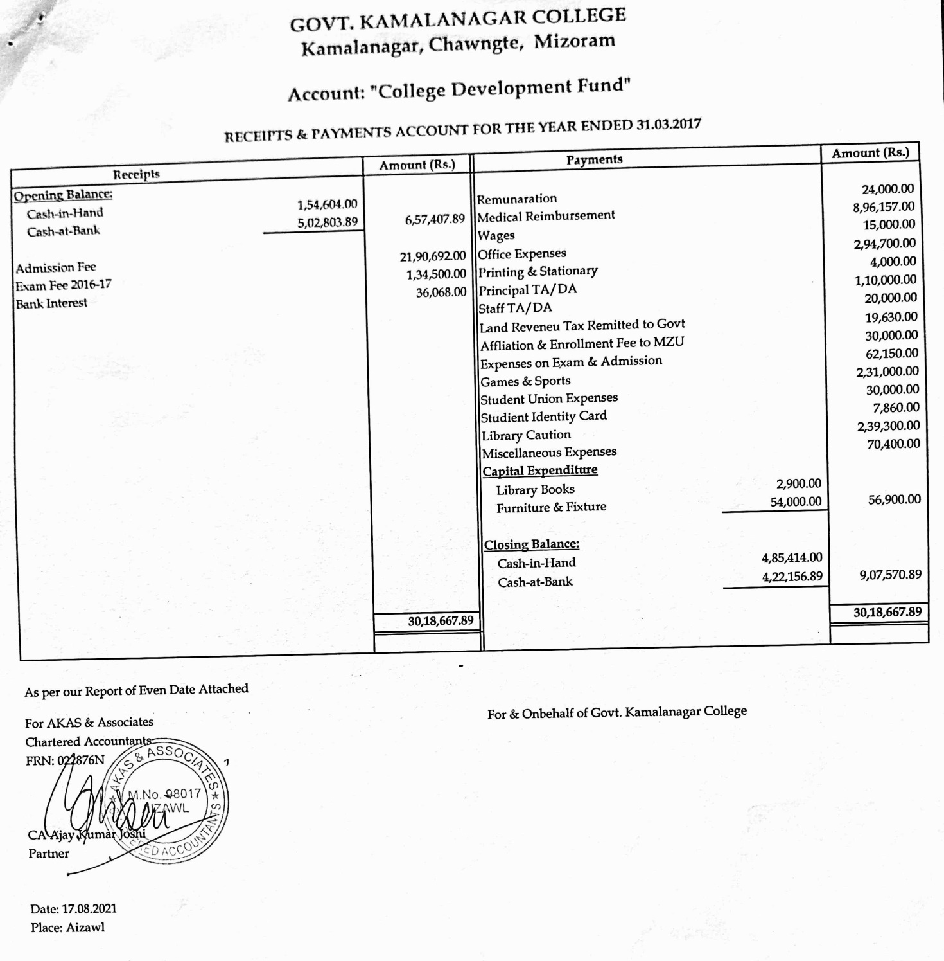

2017-2018

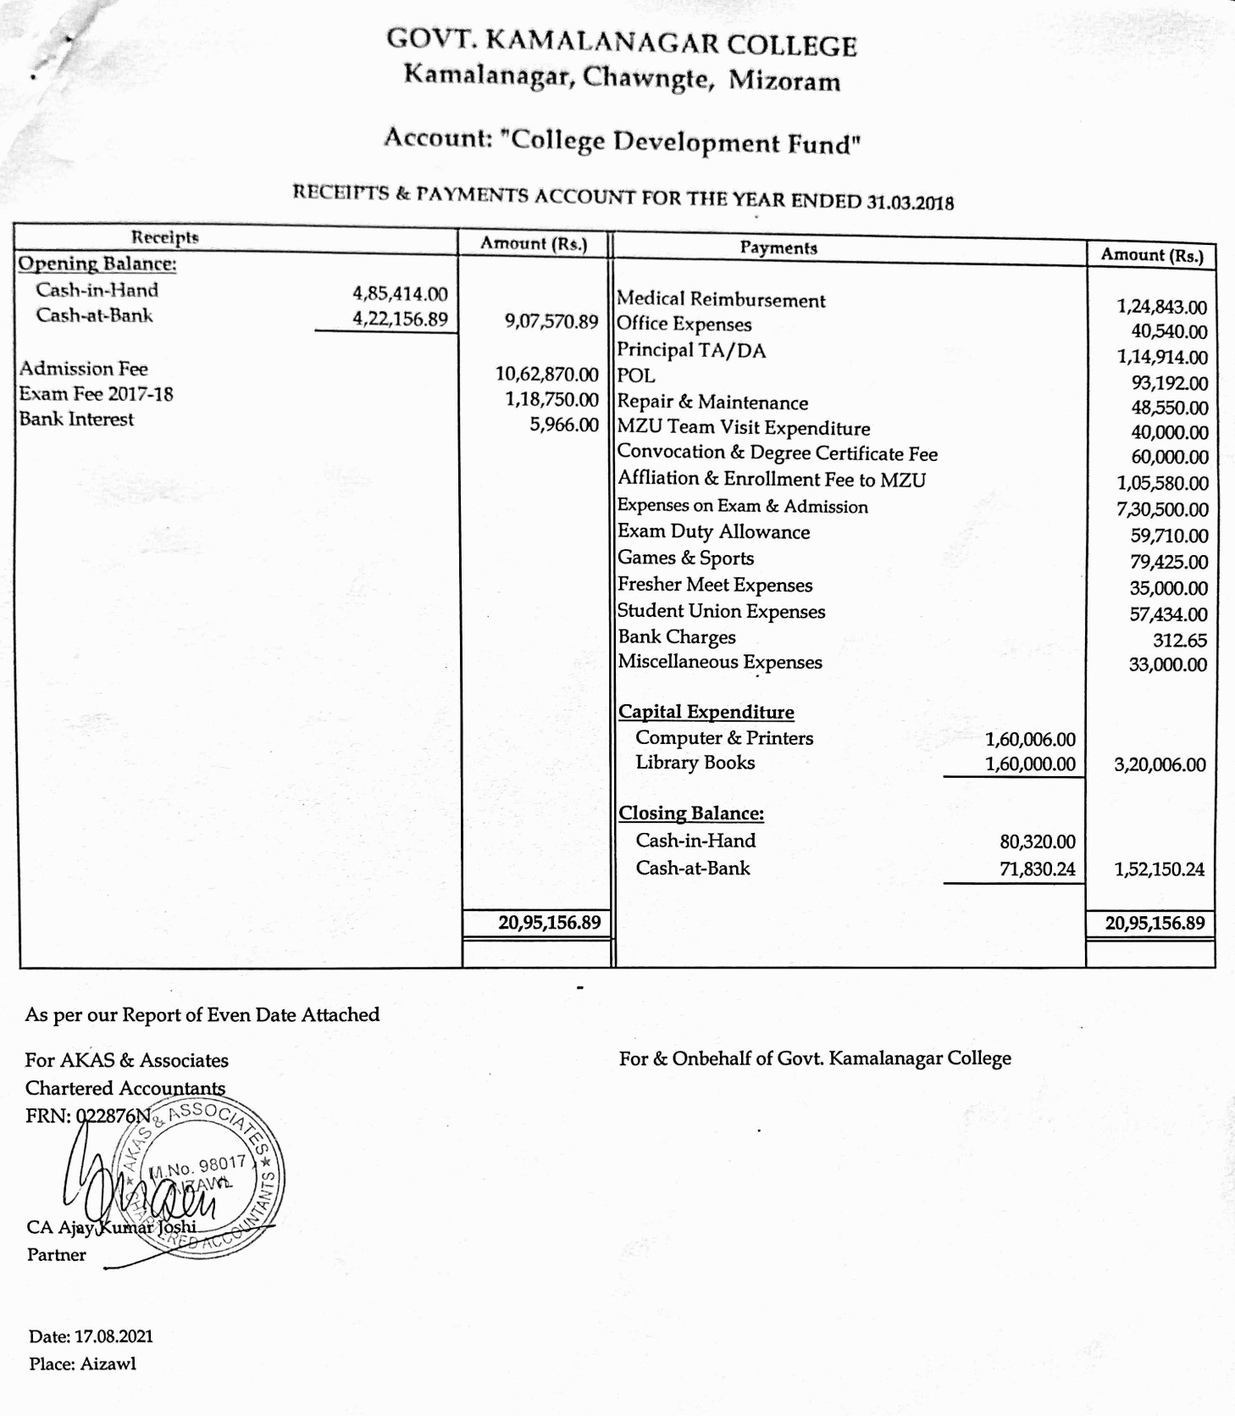

2018-2019
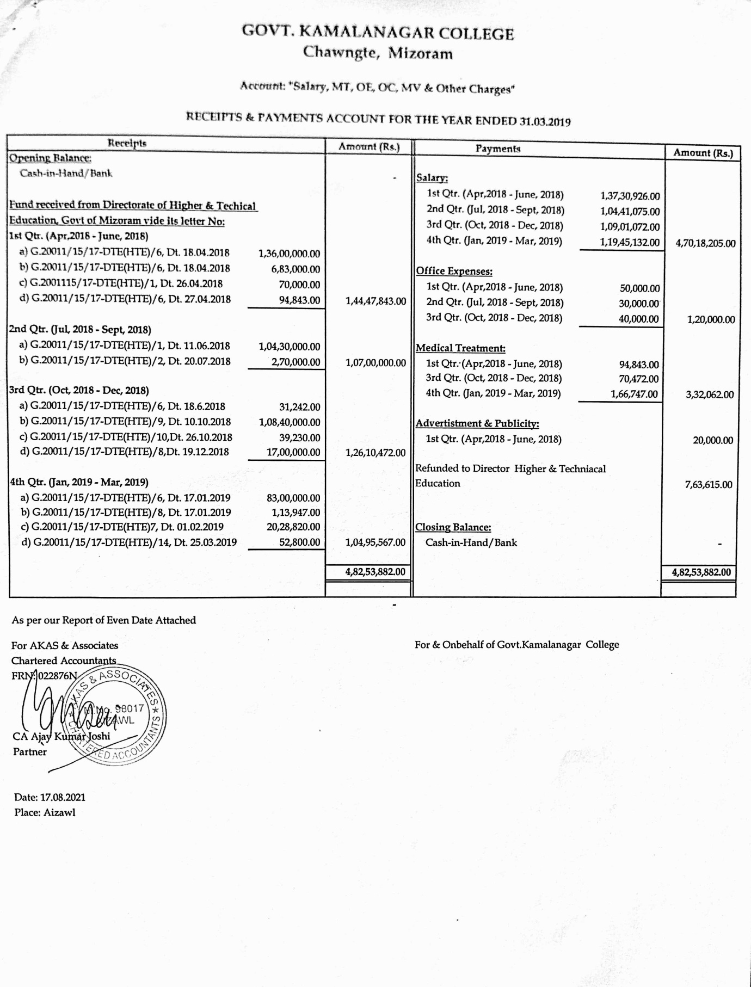

2019-2020
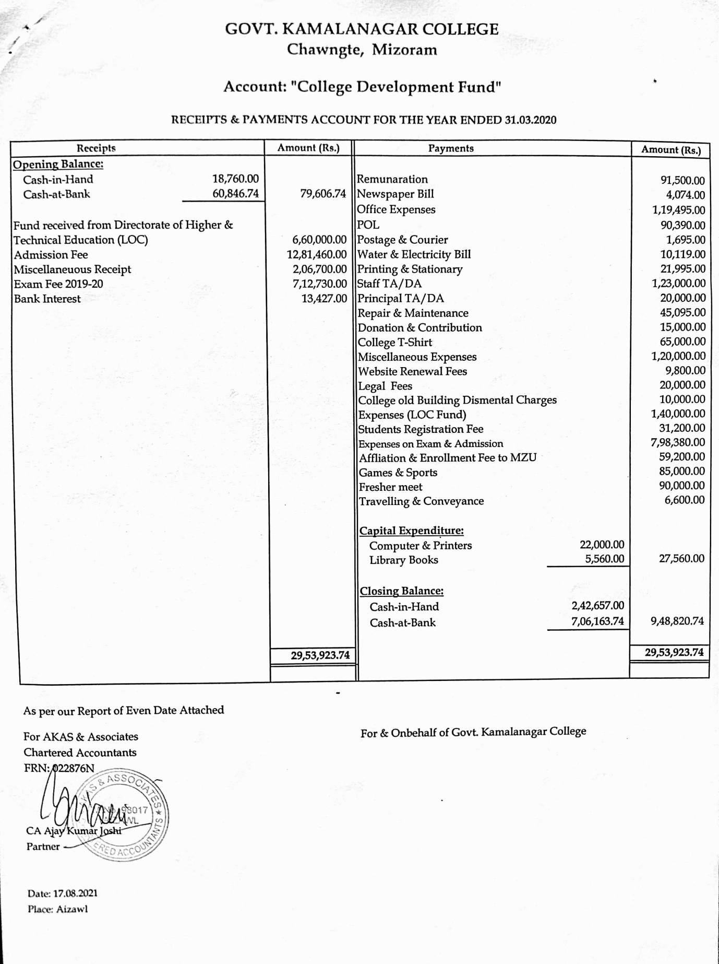

2020-2021
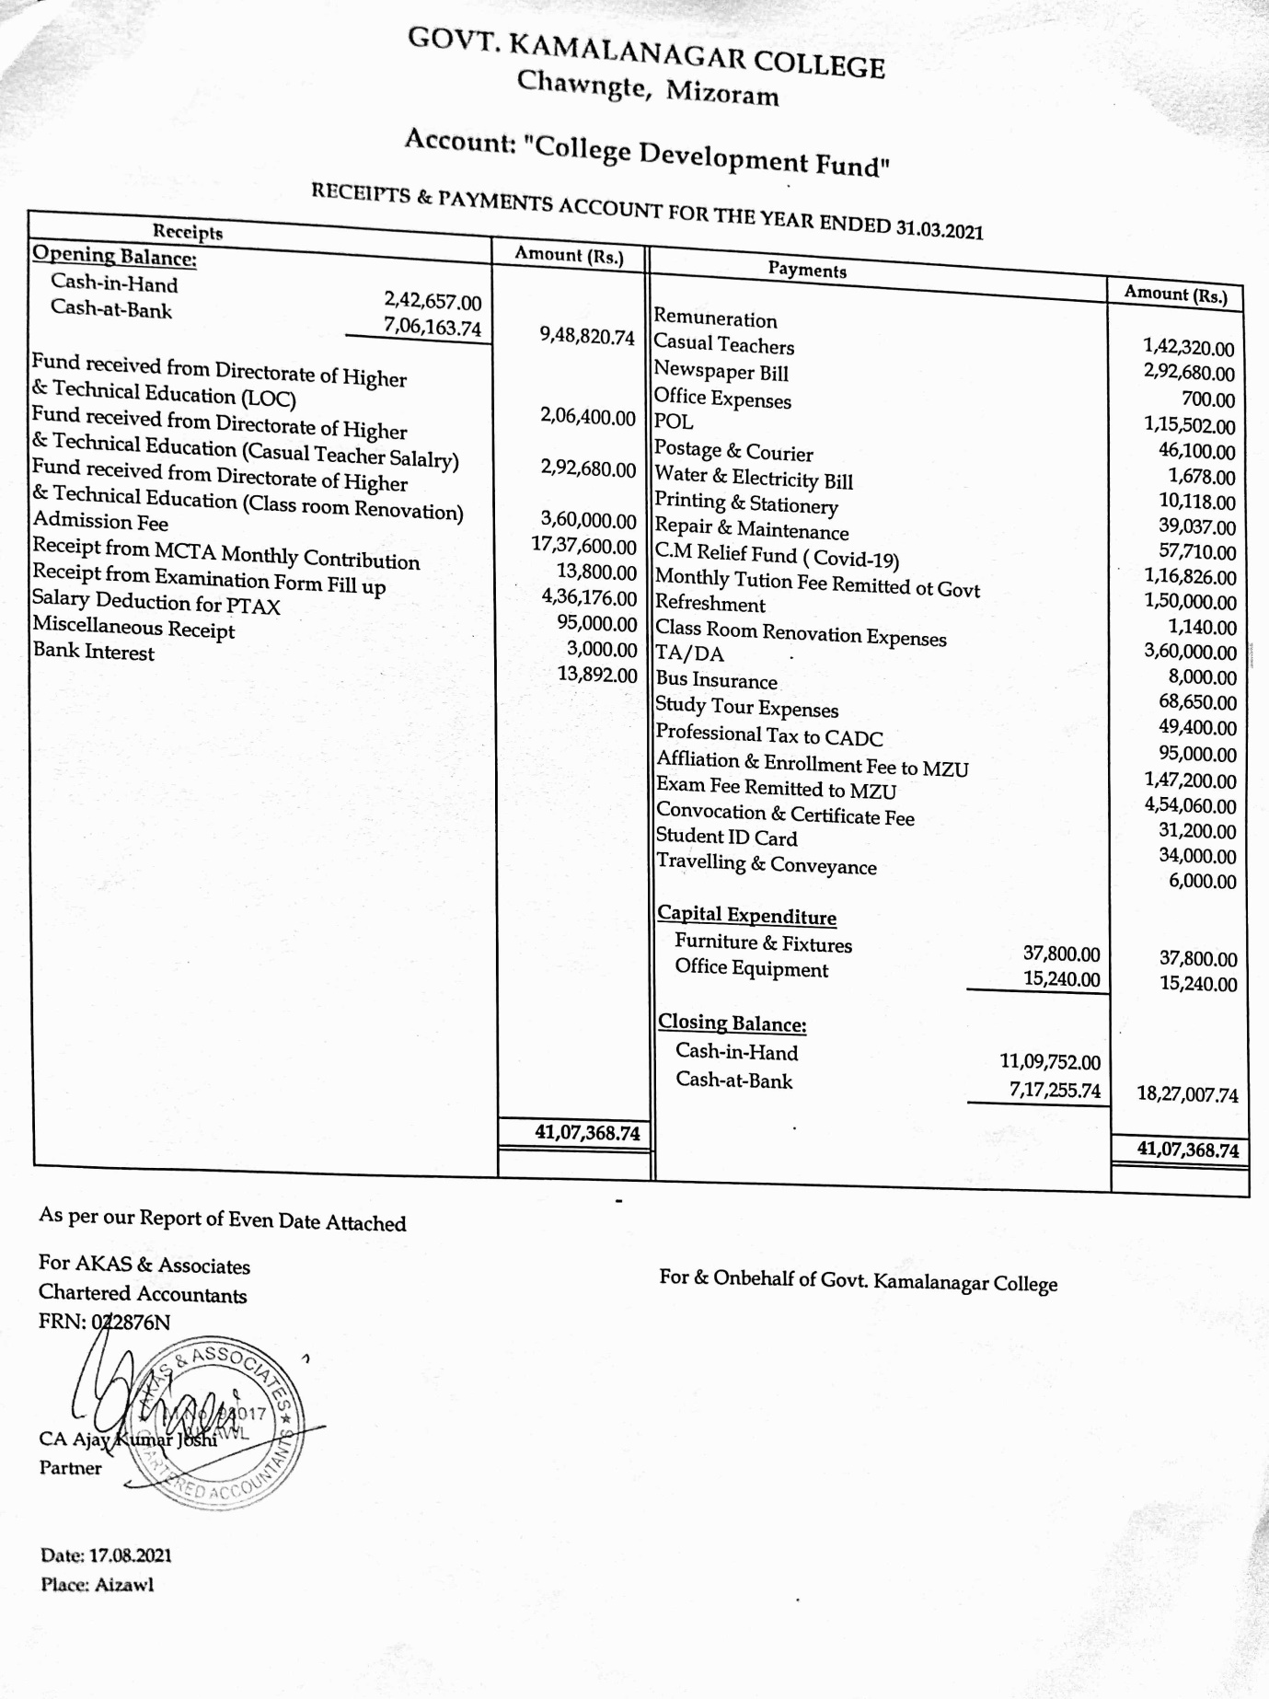

Manual - 12:

22. The Manner of Execution of Subsidy Programmes, including the amounts allocated & the details of Beneficiaries of such Programmes:

Scholarship is given by the Government to the Tribal students (SC/ST). There is a scheme to give Memento and Cash for Topper students in the University Examination, also, Subject topper from the college is to be given Memento by the department faculties.

Manual - 13:

23. Particulars of recipients of concessions, Permits or Authorizations granted by it.

Not applicable, as the college follows the Government Rules.

Manual - 14:

24. Details in Respect of the Information, Available to or held by it, Reduced in an Electronic Form:

One can visit either the college Office or Website for detail information http://www.gknc.in

Manual - 15:

25. The Particulars of Facilities available to Citizens for Obtaining Information, Including the Working Hours of a Library or Reading Room, if Maintain for Public use.

Not Available

Manual - 16:
The Names, Designations and Other Particulars of the Public Information Officers:
Sr. No. | Department / Organisation | Name | Designation | Telephone No. | Fax. No. | E-mail
1. | Govt. Kamalanagar College | Mrs Elizabeth Mannou | Principal | 7085079256 | Not available | collegekama@gmail.com

Manual - 17:

Such Other Information as may be prescribed; and thereafter update these Publications every year:

Indira Gandhi National Open School (IGNOU) Special Study Centre is available in the college campus. Courses available are : -
(i) BDP (Bachelors’ Degree Programs) in Political science, History, Public Administration, English and Economics,
(ii) MA (Master of Arts) in History, Political Science, Public Administration and English.

Information given above is true to the best of my knowledge and belief.

Contact : 7085079256
Email : collegekama@gmail.com

Sd/-
(Mrs ELIZABETH MANNOU)
Principal
&
Assistant Public Information Officer (APIO) under the RTI Act, 2005

