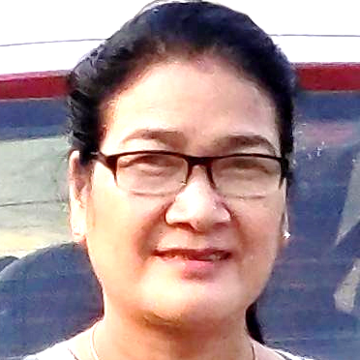
Mrs Elizabeth Man
Principal
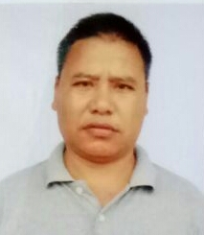
Mr Sushant Chakma,
Librarian
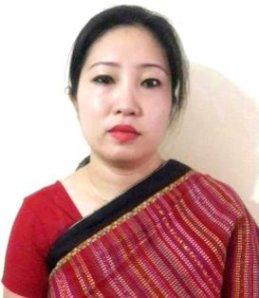
Mrs. SOMA CHAKMA, Head Asst.
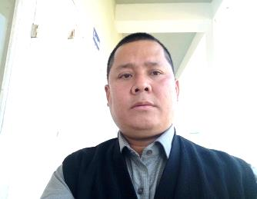
Mr. Samar Bijoy Chakma, UDC
 | 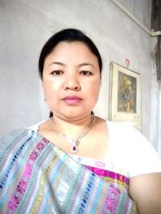  Mrs. Rupa Chakma, LDC | 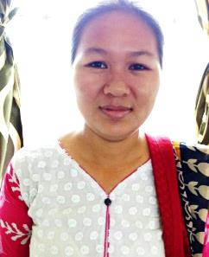  Mrs Priscilla Chakma, LDC | 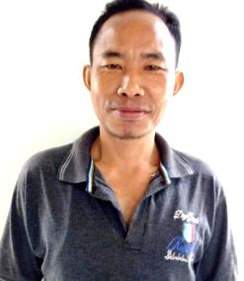  Mr. B. Begul Chakma, Ldc | VACANT
 |  |  |  | The incumbent was attached to Women Polytechnic, Aizawl
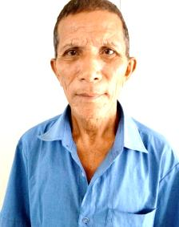  Mr. Chigon Marattya Chakma,  IV Grade | 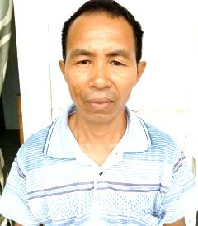  Mr Bana Chandra Chakma,  IV Grade | 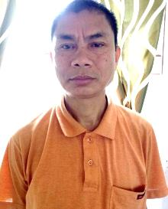  Mr. Bijoy Kanti Chakma,  IV Grade | 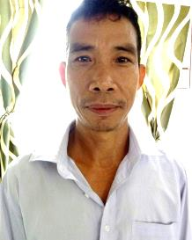  Mr. Dayal Kumar Chakma,  IV Grade | 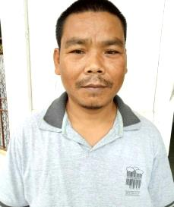  Mr Hiron Moy Chakma,  IV Grade |  | 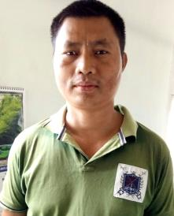  Mr. Bishnu Mohan Chakma, IV Grade

