DEPARTMENT OF ENGLISH
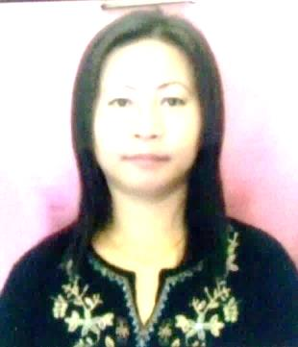 | 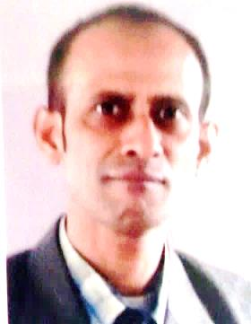 | 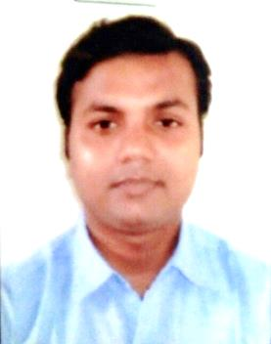 |  | VACANT
Mrs H. Vanlalveni  MA(Eng), M.Phil  Assistant Professor  Head of Department  Ph.: 9402322565 | Mr Pankaj Roy  MA(Eng), UGC-NET  Associate Professor  Ph.: 9436387286 | Dr Satyajit Das  MA(Eng), UGC-NET  Associate Professor  Ph.: 9436781807 | Ms P.C. Lalrinmuani  MA(Eng), UGC-NET  Assistant Professor  Ph.: 7674055428 | The incumbent was attached to Govt. J. Thankima College, Aizawl

DEPARTMENT OF MIZO
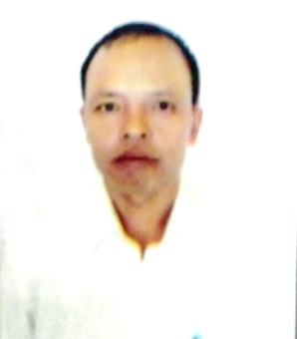 | 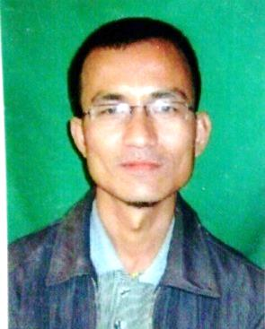 |  | VACANT | VACANT
Mr ZD Ramngamzaua  MA(Mizo)  Assistant Professor  Head of Department  Ph.: 9436956482 | Mr Lalremliana  MA(Mizo)  Assistant Professor  Ph.: 9436784808 | Mrs K. Zonunmawii  MA(Mizo)  Assistant Professor  Ph.: 9436159112

DEPARTMENT OF HINDI
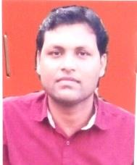 |  | 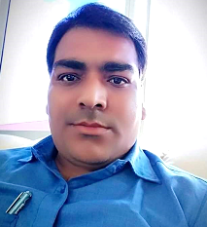
Dr Ratan Kuma  MA(Hindi), PhD  Assistant Professor  Head of Department  Ph.: 9436965444 | Mr Harry Prasad  MA(Hindi), UGC-NET  Assistant Professor  Ph.: 9436755565 | Dr Dheerendra Kumar Srivastav  MA (Hindi), PhD  Assistant Professor  Ph.: 8707502283

DEPARTMENT OF ECONOMICS
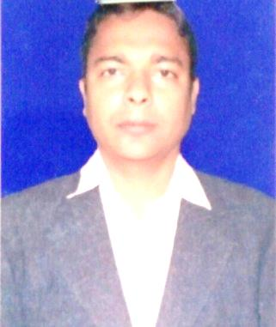 | 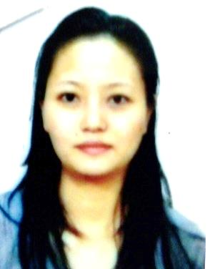 | VACANT | VACANT
Mr Sukanta Majumdar  MA(Eco), M.Phil  Assistant Professor  Head of Department  Ph.: 948510589 | Mrs F. Lalrinnghinglovi  MA(Eco), UGC-NET  Assistant Professor  Ph.: 9436388316

DEPARTMENT OF HISTORY
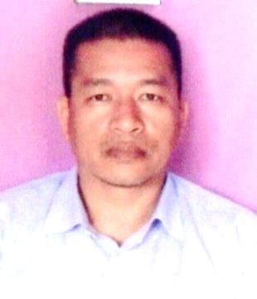 | 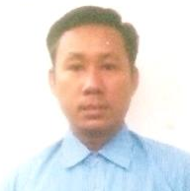 | 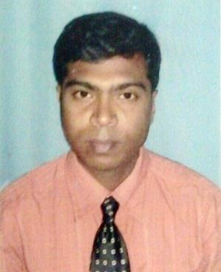 | VACANT
Mr Lalthamuan Neihsial  MA(Hist), UGC-NET  Assistant Professor  Head of Department  Ph.: 7085639165 | Dr Jyotir Moy Chakma  MA(Hist), Ph.D.  Associate Professor  Ph.: 7085902145 | Mr Sanjeev Kumar Dey  MA(Hist), M.Phil  Associate Professor  Ph.: 7085402372

DEPARTMENT OF POLITICAL SCIENCE
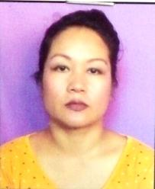 | 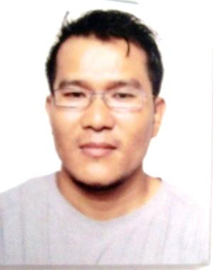 |  | VACANT
Mrs R. Laldingliani  MA(Pol.Sc), UGC-NET  Assistant Professor  Head of Department  Ph.: 7308290214 | Dr Sukro Kumar Chakma  MA(Pol.Sc), SLET, PhD  Assistant Professor  Ph.: 9863392775 | Dr Vanlalpari  MA(Pol.Sc), UGC-NET, MPhil, PhD  Assistant Professor  Ph.: 8800920376

DEPARTMENT OF PUBLIC ADMINISTRATION
 | 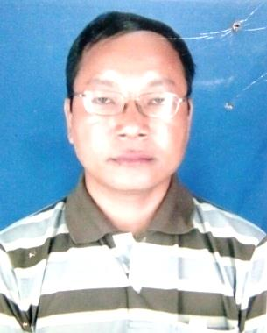 | 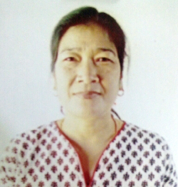 | VACANT
Mrs Lalfakzuali  MA(Pol.Sc), UGC-NET  Assistant Professor  Ph.: 9436755081 | Dr Sakhawliana  MA(PA), PhD,UGC-NET  Assistant Professor  Ph.: 9862356932 | Mrs Elizabeth Mannou  MA (PA)  Associate Professor  (I/c Principal) | The incumbent was attached to Govt. Aizawl West College, Aizawl

DEPARTMENT OF EDUCATION
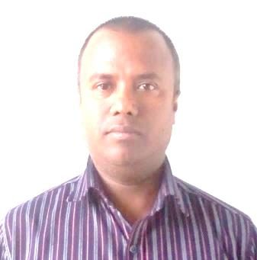 | 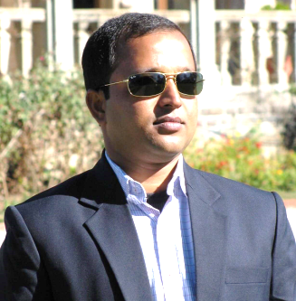 |  | VACANT
Dr Debasish Paul  MA(Edu), MA(Phil&Rel), PhD, UGC-NET  Associate Professor  Head of Department  Ph.: 7002129725 | Dr Pulak Chandra Devnath  MA(Edu), PhD  Assistant Professor  Ph.: 8732853855 | Mrs Biakthansangi  MA(Edu), M.Phil  Assistant Professor  Ph.: 9612722896

